BRAT Open Water Swimming

Course Map

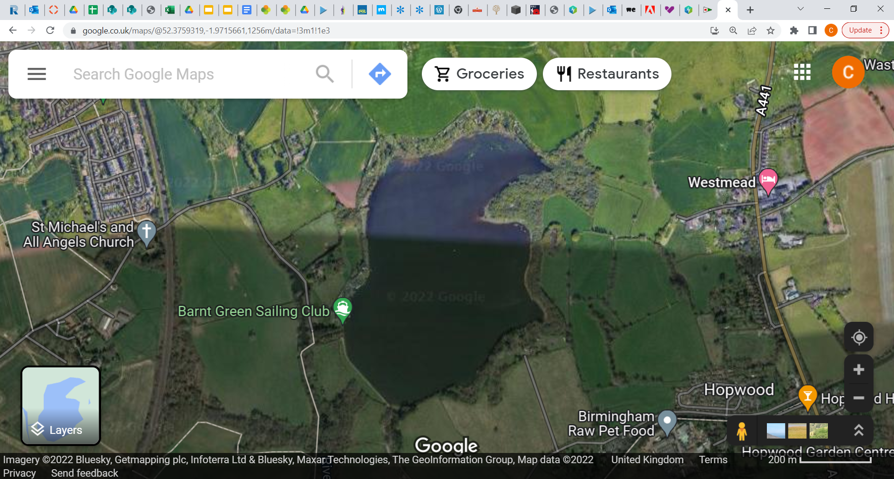

[Grab your reader’s attention with a great quote from the document or use this space to emphasize a key point. To place this text box anywhere on the page, just drag it.]

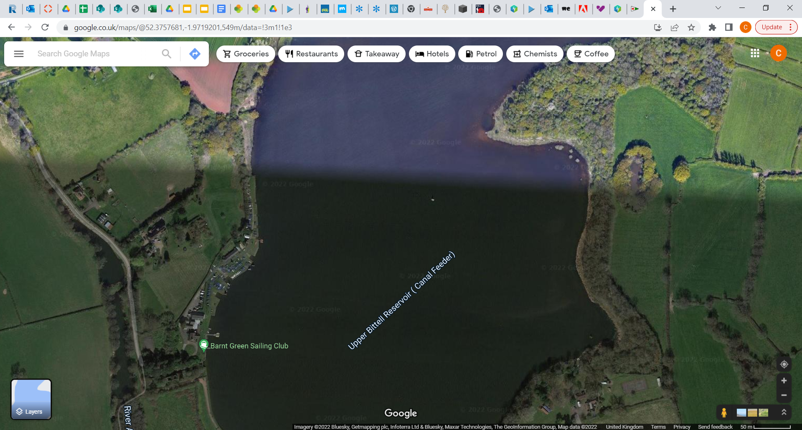

Course total length: 450m

Entry and Exit via slipway next to registration.

Buoy 3-1: 175m

Buoy 2-3: 175m

mm

Buoy 1-2: 100m